EXPERIMENT - 1
ROLL NO: 240701044 NAME: ZARAAJUHI SAAI K

USER INTERFACE AND DESIGN
COMPARISON OF UI DESIGN BETWEEN TWO FIGMA CREATION

BAD POSTER
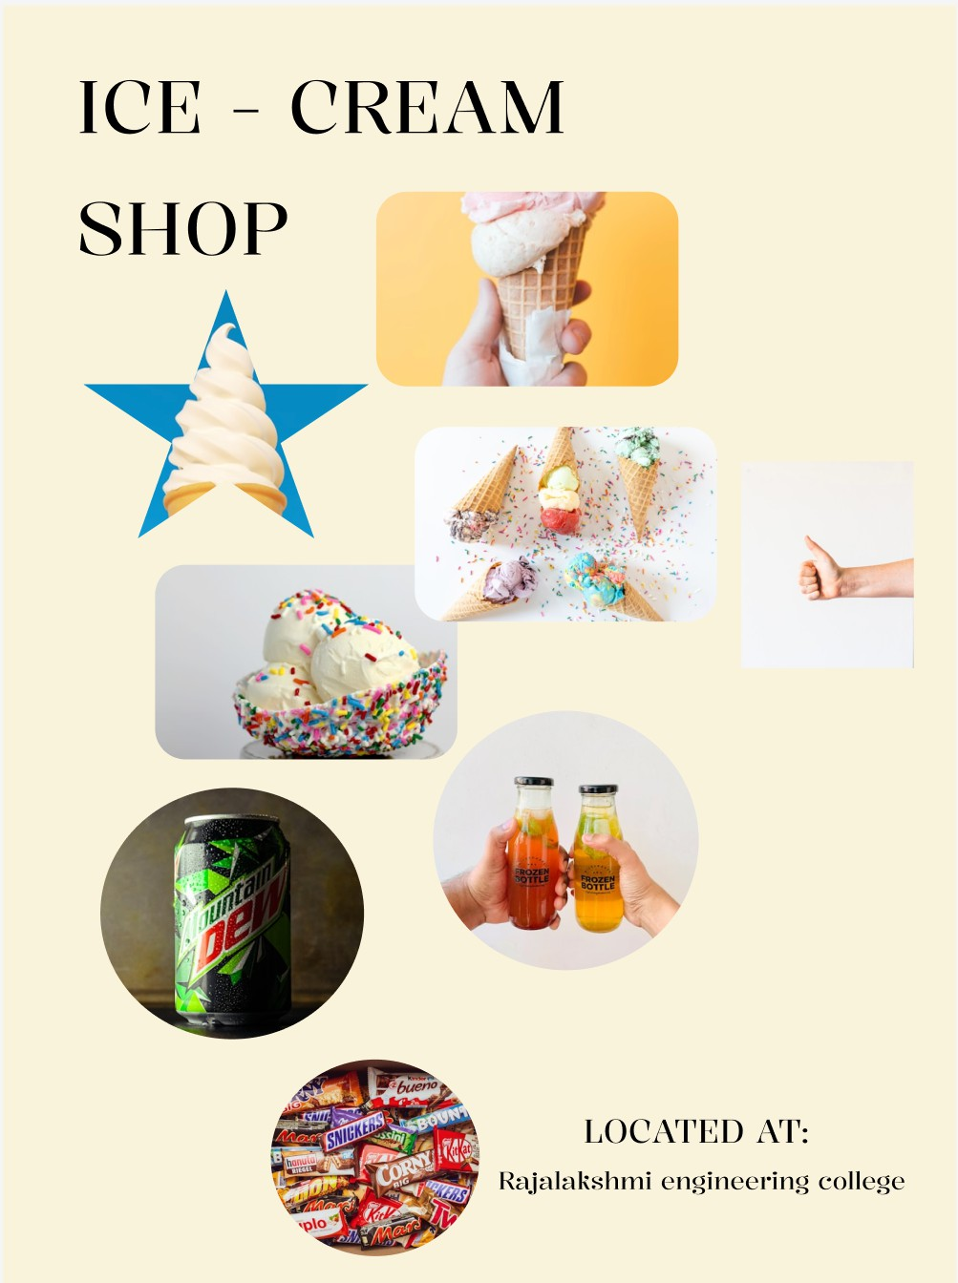

GOOD POSTER
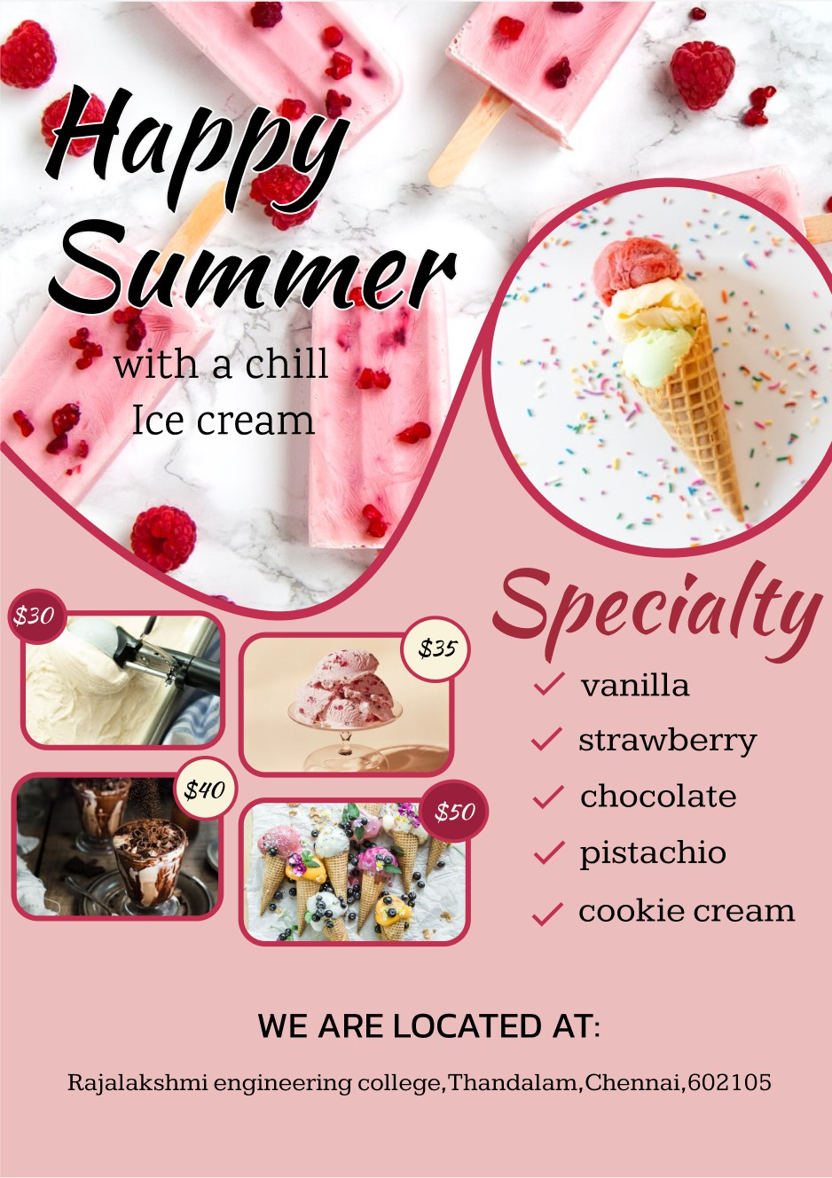

PROTOTYPE LINK:
https://www.figma.com/design/XVlNbzvGx7VtAc3hBS5ZEm/ice-cream-temp?node
-id=0-1&p=f&t=ez5a5dWmIH1NM0KM-0

COMPARISON OF GOOD DESIGN AND BAD DESIGN

BAD DESIGN

Design style:

- Lacks visual and consistency.
- Poor color combination and random image placement.

Content:
- Very minimal information.
- No clear highlight or attractive message.
- There is no price of the product.

Layout:

- Improper alignment and spacing.
- No visual hierarchy ; difficult to understand at first glance .

Purpose:
  - Fails to attract attention.
  - Does not effectively promote the ice cream shop or its products.

GOOD DESIGN

Design Style:
- Clean, attractive and professional layout.
- Suitable color palette matching the ice-cream theme.

Content:
- Clear heading and well organized product details.
- Important information is easy to read and understand.

Layout:
- Proper alignment and spacing.
- Clear visual hierarchy guides the viewers attention.

Purpose:
- Effectively promotes ice-cream.
- Attracts customers and communicates information clearly.

KEY DIFFERENCE:
The bad poster lacks clarity, structure and visual appeal, whereas the good poster follows basic design principles such as alignment ,contrast and hierarchy ,making it more effective and visually appealing.

